**Celebration in Worship**

**Ninth Sunday after Pentecost**  
**August 11, 2019**

We believe the words of Jesus reflect the heart of the Divine:

“I will never turn away anyone who comes to me.”

John 6:37

**GATHERING AROUND THE WORD**

**PRAYER OF PREPARATION**

O God of promise, creator of the cosmos, you are the first light breaking through the void and the final light we shall eternally enjoy. Keep our hearts ever vigilant as we wait to welcome you, that you would find us clothed in love, dressed for action and eager to receive you. Amen.

**PRELUDE**

**WELCOME AND ANNOUNCEMENTS**

    The Lord be with you.

**And also with you.**

**\*CALL TO WORSHIP**

We are people who have been called  
to follow where God leads us.  
**By faith we can obey,**

**even when asked to walk into an unknown future.**

We are people who have been challenged  
to tell God's story to others.  
**By faith we have the ability to share the good news.**

We are God's children who are invited  
to feast at the Table of grace.  
**By faith we will embrace our sisters and brothers in Christ.**

**\*HYMN 104 *O Lord, How Shall I Meet You*** *Glory to God**Hymnal*

**CALL TO CONFESSION**

We would like to keep our sins hidden and our failures a secret. But God would not have us keep silent, but speak our confessions out loud, so we may be blessed with God's mercy and grace. I invite you to pray with me, saying,

**PRAYER OF CONFESSION**

**You have a vision of all people as your beloved children, Imaginative God, but we see folks whose language, dress, and skin make them different. You have a vision of a universe filled with goodness and beauty, and we damage it with litter, with violence, with poor choices. Forgive us, Merciful God. By faith, may we be willing to be as gracious, as compassionate, and as hopeful as you are. You love us enough to want us to be with you forever, so may we take the hand of our Lord and Savior, Jesus Christ, who leads us in your Way.**

*A period of silent prayer is observed.*

**PROCLAIMING THE WORD**

**ASSURANCE**   
There is nothing to fear. God's hope is more tenacious than our despair; God's joy is more resilient than our grief; God's love is more compelling than our hate.

**By grace, we are gathered to God.**

**By faith, we rest in God's promises of forgiveness and restoration. Thanks be to God! Amen.**

**SUNG RESPONSE 750 Goodness Is Stronger than Evil** *Glory to God Hymnal*

**\*PASSING THE PEACE**

The Peace of Christ be with you

**And also with you.**

**CHILDREN’S MESSAGE**

**SPECIAL MUSIC My Life Flows On** Nicolette D’Erazo

**SCRIPTURE LESSON       Luke 12:32-40**

**SERMON *Dressed & Ready***

**RESPONDING TO THE WORD**

**\*HYMN 366 *Love Divine, All Loves Excelling*** *Glory to God Hymnal*

**AN INVITATION TO OFFERING**

Jesus said, “Sell your possessions, and give alms. For where your treasure is, there your heart will be also.” Let us honor God with a sacrifice of thanksgiving and come into God’s courts with praise as we receive this morning’s offering.

**OFFERTORY**

*Please use the yellow prayer request cards found in the pew and place them in the offering plate to be included in the prayers of the people and/or the email prayer ministry of CPC.*

**\*DOXOLOGY***(Unison)*

**Praise God, from whom all blessings flow;**

**Praise God, all creatures here below:**

**Alleluia! Alleluia!**

**Praise God, the source of all our gifts!**

**Praise Christ, whose mighty power uplifts!**

**Praise the Spirit, Holy Spirit!**

**Alleluia! Alleluia! Alleluia!**

**PRAYER OF DEDICATION, PRAYERS OF THE PEOPLE**

**& THE LORD’S PRAYER**  
It is by faith that you bless us, hopeful God. So, it is by faith that we offer back to you a portion of what we have and who we are, trusting that you will take these gifts and use them in the work of that kingdom of justice and hope, of grace and wonder, which is yours. Trusting you, we bring also the prayers of this community . . .

**Our Father who art in heaven, hallowed be thy name.**

**Thy kingdom come, thy will be done,**

**on earth as it is in heaven.**

**Give us this day our daily bread,**

**and forgive us our debts, as we forgive our debtors,**

**And lead us not into temptation, but deliver us from evil.**

**For thine is the kingdom and the power**

**and the glory, forever.  Amen.**

**\*CLOSING HYMN 748 *Go with Us, Lord*** *Glory to God Hymnal*

**\*CHARGE & BENEDICTION**

**POSTLUDE** CCLI 1023827

* *Indicates a time in the service when you are invited to rise in body or spirit.*

**Bold passages indicate unison reading.**

Visitors, friends, members, welcome to worship! Please feel free to participate in ways that you feel led, and comfortable if you would just like to observe. We welcome your presence and invite you to join in the Fellowship Hall after the worship service.  If you are interested in learning more about making Central Presbyterian your church home, please speak with Pastor Jennifer or the welcome greeter following the service.

Visitors, friends, members, welcome to worship! We are glad you are here and invite you to join us for coffee after the worship service.

**THIS WEEK AT CENTRAL**

**10:00am Worship, Sanctuary**

**11:00am Fellowship, Fellowship Hall**

**OFFICE HOURS**

**Monday – Thursday, 8:30am-12:30pm, 1:30pm-4:00**

**Friday - Closed**

Mon, Aug 12 11:00am Bible Study Parlor

4:30pm Worship & Common Life Pastor’s Office

6:30pm Badminton Group Fellowship Hall

Tues, Aug 13 10:30am All-Staff Meeting Pastors Office

1:30pm Church Properties Pastor’s Office

3:00pm Personnel Committee Pastor’s Office

Wed, Aug 14 4:30pm Central Beach Party Patterson St. Lawn

**THE SIXTH ANNUAL “CENTRAL BEACH PARTY/PICNIC”** will be **Wednesday, August 14 from 4:30-6:00pm** on the Patterson St. lawn. The Ministry of Worship and Common Life will serve baked beans, hot dogs, condiments and beverages. Participants are asked to bring side dishes and desserts. Bring lawn chairs if you can. Join us for beach music and lawn games. Please contact Julianne Stermer at 541-726-4942 for more information about this event.

[](https://www.bing.com/images/search?view=detailV2&ccid=xm3J6sU/&id=3618DF574DCB4C6E009F6C9D06588E98DC1C86EF&thid=OIP.xm3J6sU_0_-UlL1NnyAoXQHaLq&mediaurl=https://s-media-cache-ak0.pinimg.com/736x/a8/5a/aa/a85aaa8edc392074bb80b474c864988f.jpg&exph=1159&expw=736&q=flowers+clipart&simid=608053199259895287&selectedIndex=212)

**FLOWERS TODAY** – Have been given to the Glory of God by Gerry & Carolyn Keener in memory of Don Leslie and in honor of his generosity by sharing the bounty of his produce garden with his fellow church members.

[](https://www.bing.com/images/search?q=book+club+clip+art&id=CF45D59A0F0902753A9E8746588F24062A5CE78C&FORM=IQFRBA)**CPC Wednesday Book Group Suggestions Welcome!** Our weekly book group will be starting up again this fall. In preparation for that Pastor Jennifer is soliciting your suggestions for books that might be good to read in a community of faith. Please send any suggestions you have to her at [centralpcjen@gmail.com](mailto:centralpcjen@gmail.com) by August 15th. Also, if you would like to be added to the book group email list, just let her know!

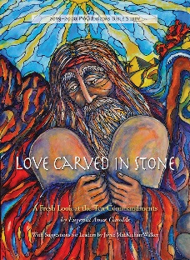

**PW CIRCLES RESUME MEETING IN SEPTEMBER –** *Love Carved in Stone, A Fresh Look at the Ten Commandments,* by Eugenia Anne Gamble is the 2019-2020 Bible study. Books are now available in the church office for $11.

**BIRTHDAYS THIS WEEK**

12 Jordan Ryder

14 Pooyesh Ganji

16 Barbara Belknap

17 Richard Lin

**STRICTLY ORGANIC COFFEE,** for $14 a pound, is available in the Narthex from Merle Bottge after worship today. Buy a bag of decaf or regular coffee; it's certified organic, shade grown, and farmer friendly. Any profit Central makes will be given to Presbyterian Disaster Assistance.

**FISH** – Fruit is one item that FISH does not purchase but is happy to distribute when it can. Canned applesauce and peaches, dried raisins and apricots. Give what you enjoy eating. Place your donations in the wicker basket on Sunday, and they will be provided to those who seek help from FISH.

**THE COIN OFFERING –**-

**Coin Offerings for August -** are designated for SquareOne Villages. SquareOne Villages is a non-profit organization dedicated to creating self-managed communities of cost-effective tiny homes for people in need of housing. These include Opportunity Village and Emerald Village in Eugene and Cottage Village in Cottage Grove. Members of Central have been actively involved and served on the Board of SquareOne Villages. The National Presbyterian Women gave a $100,000 grant to Cottage Village, and construction has begun on the first home. SquareOne seeks to bridge the gap between living on the streets and conventional housing with a variety of simple cost effective housing options. Thank you for supporting them with your coins on Sunday morning.

***We thank the following faithful people who***

**Lectionary –**

**Sunday, August 18**

**Isaiah 5:1-7**

***Ps. 80:1-2, 8-9***

**Hebrews 11:29-12:2**

**Luke 12:49-56**

***are helping behind the scenes today:***

***Coffee Hour Fellowship Committee***

***Deacon on Call Quentin Holmes***

***Worship Leader Nancy Richter***

***Welcome Greeter Louise DeKluyver***

***Transport Team Margaret Knudson***

***Pastor Rev. Jennifer Martin***

***Organist Dan Rinnan***

***Building Host Joe Olney***

***Sound Technician Alex Pratt***

***Ministers All***





**A CARING, INQUIRING, INCLUSIVE**

**COMMUNITY OF FAITH**

**August 11, 2019**

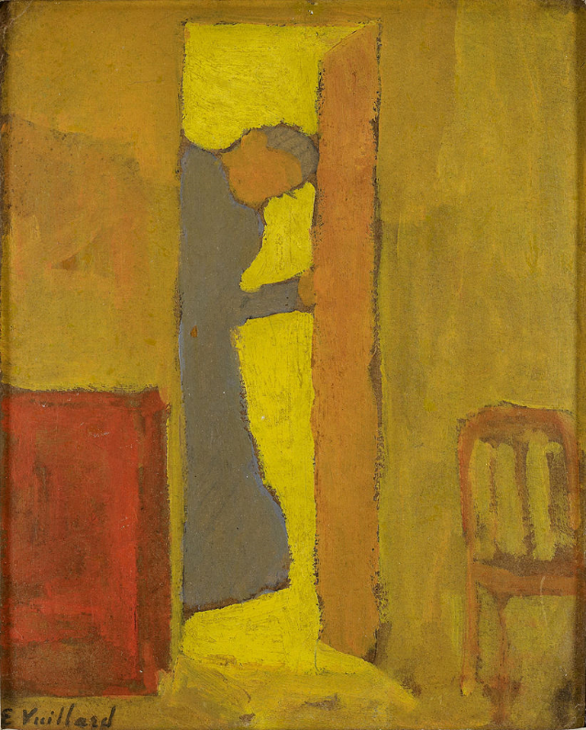

***Artist’s Mother Opening a Door*, Vuillard, Édouard, 1868-1940.**

**Minneapolis Institute of Art**

**555 East 15th Avenue, Eugene, OR 97401**

[email:centralpresbyterianeugene@](mailto:email:centralpresbyterianchurch@att.net)gmail.com

**www.centraleugene.church**

**541- 345-8724** *Find us on Facebook at Central Presbyterian Church Eugene OR*